Mallu Sravana Sandhya

SQL Coding Assignment

13/12/2023

Created a database customer and the used the same to create the tables to perform the joins and subqueries

1.First created a customer1 table with cid,cname,phno as columns and inserted 3 records into it

Then order1 table is created with oid,price,oname as columns and inserted 4 records into it in which two record oid is same as cid in customer1 table

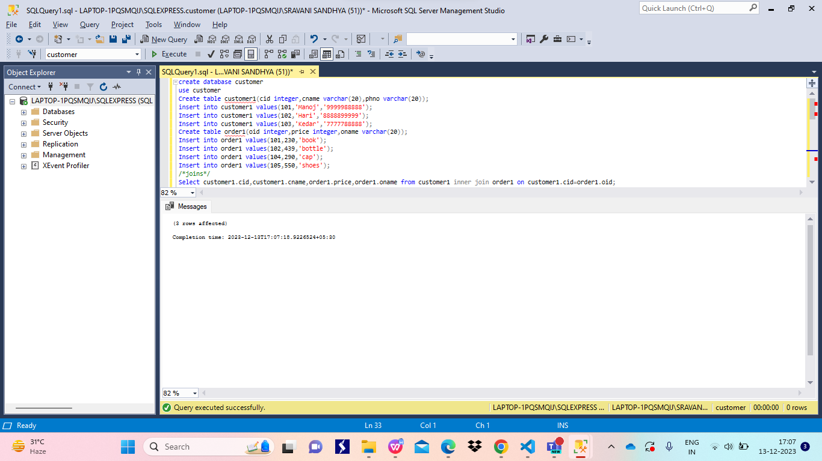

Performed inner join which joins customer1 table and order1 tables whose oid and cid are same 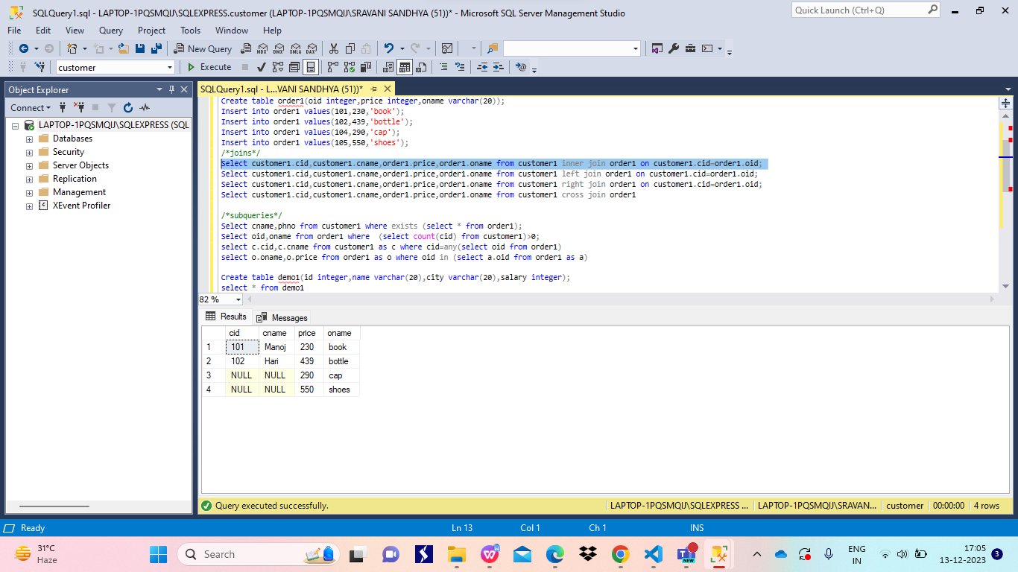

Performed left join on both tables which gives the following results 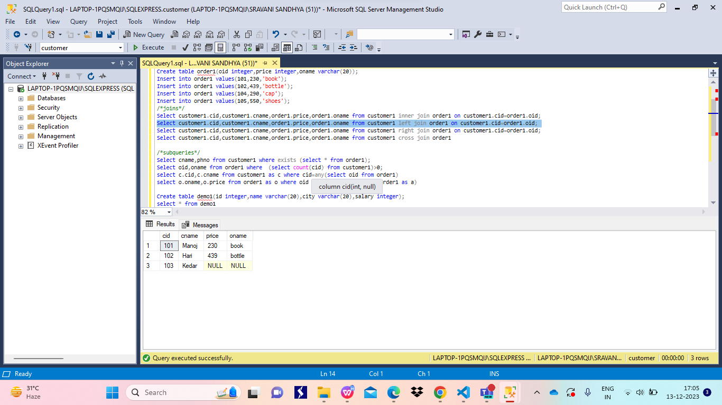

Performed right join on both the tables 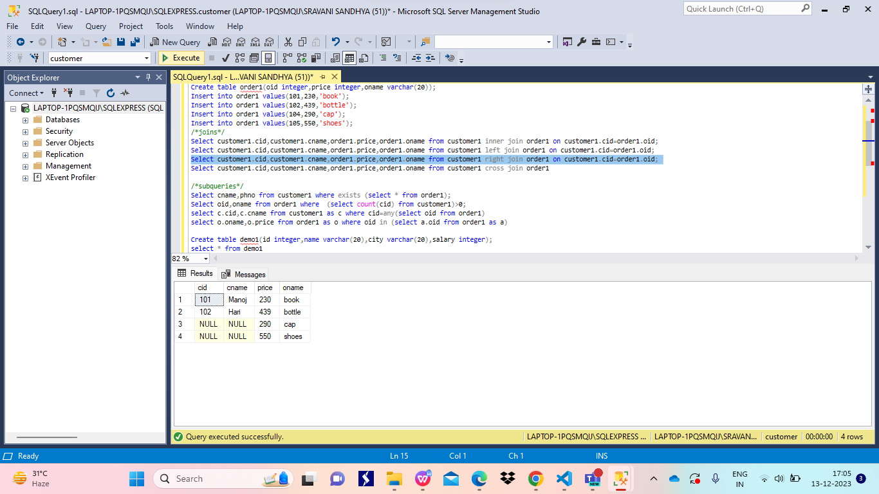

performed cross join on both the tables 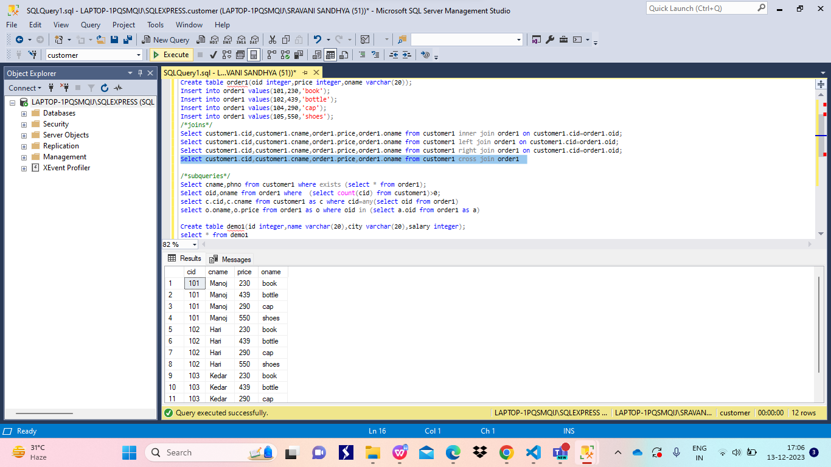

Performed subqueries and corelated subqueries on customer1 and order1 tables which results as following 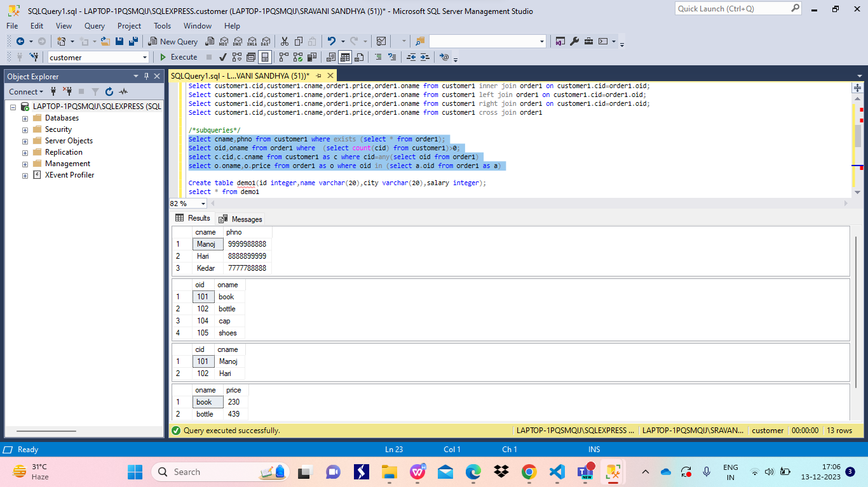

1. Created a demo1 table with id,name,city,salary as columns and inserted 3 records into the table which is shown below fig 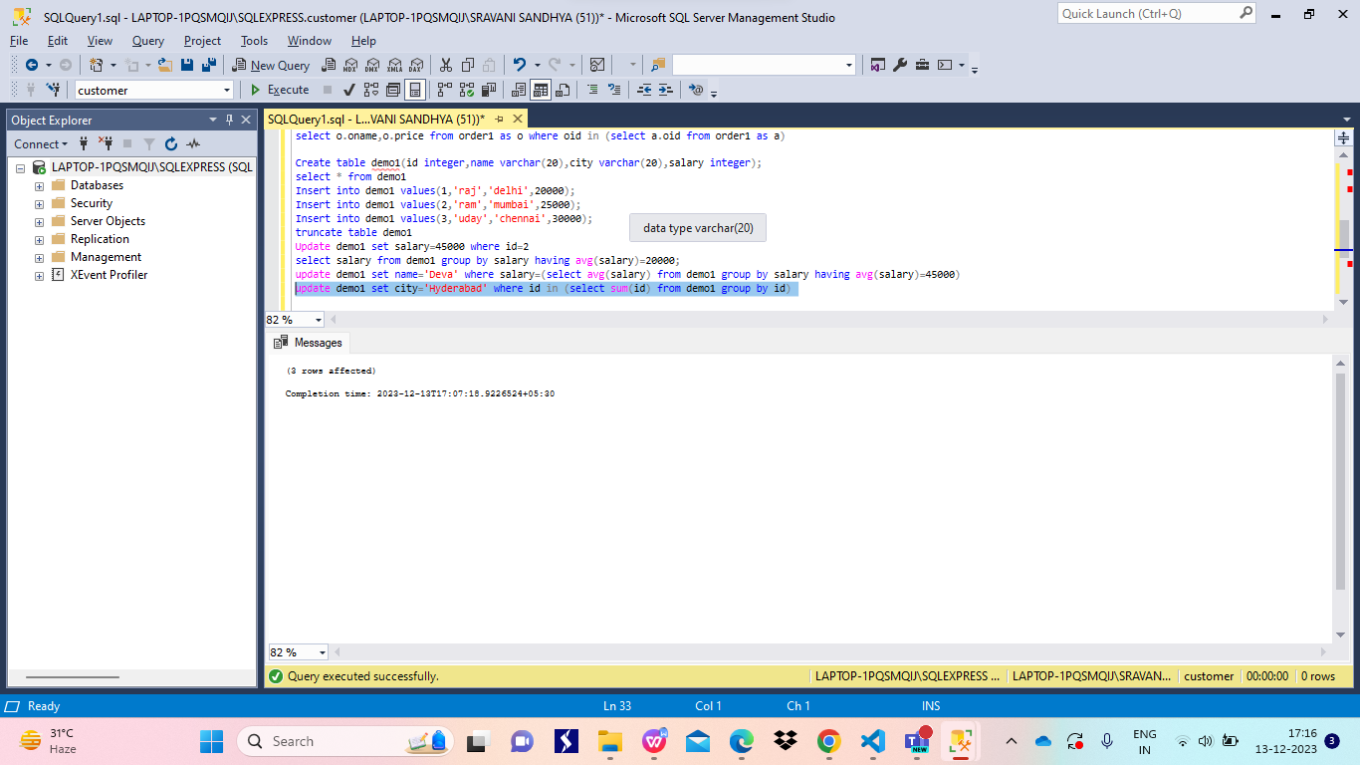

Updated the salary of a person with id as 2 to 45000 using update command and where clause

Then updated the table whose average salary is equal to 4500 the name is as Deva using group by and having clause with the help of update command 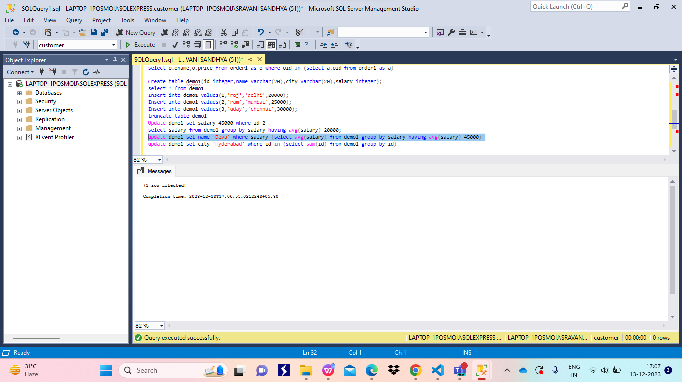

The table demo1 is updated ascity as amaravathi whose sum of id is less than 1 using group by and having clause 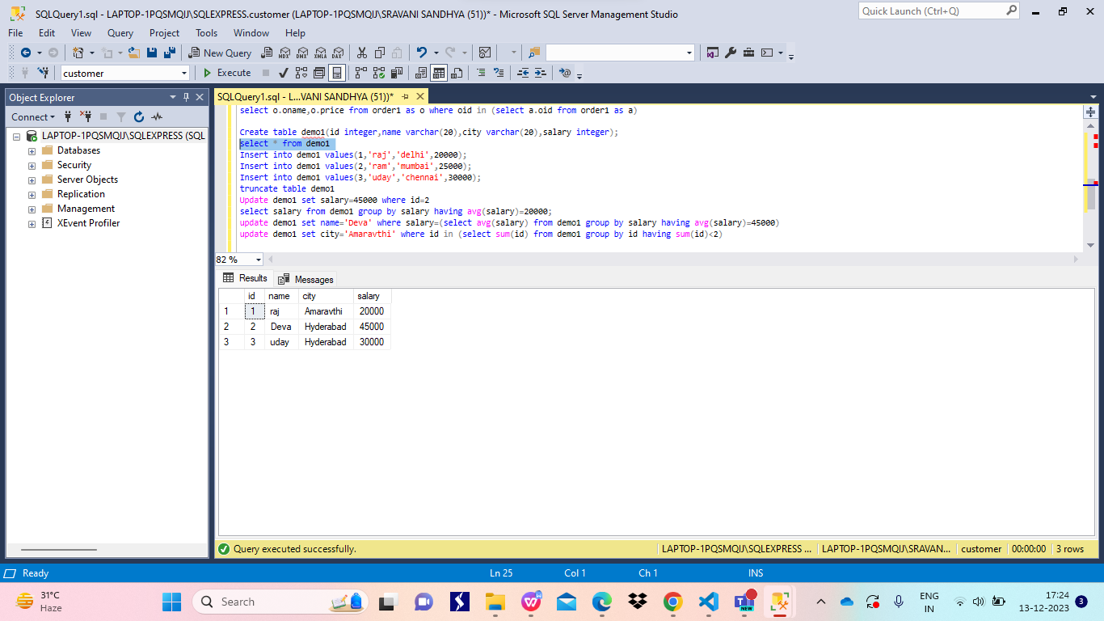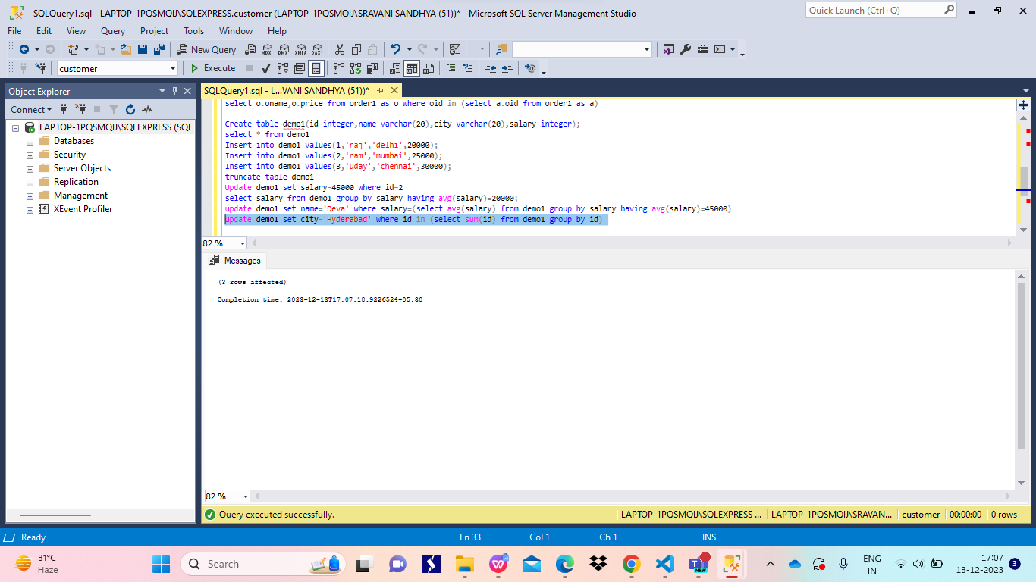

Salary is retrived from demo1 table using group by 